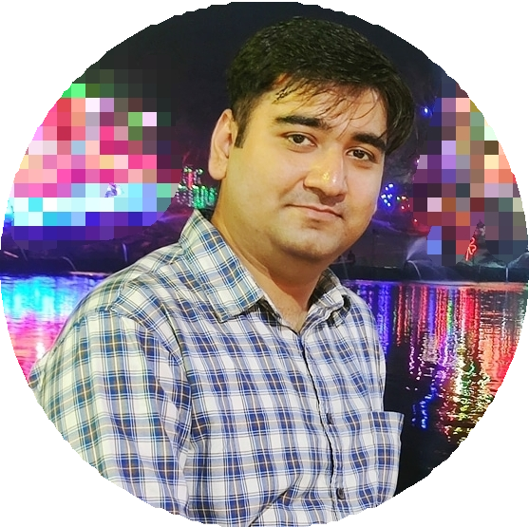

**FULLSTACK SOFTWARE DEVELOPER / WEB DEVELOPER**

**Pavas Goswami**

# PROFILE

Searching for the opportunity to bring 3+ years of experience with software developing, technology engineering, designing, and maintenance to cater to the specific needs of the people with critical thinking, problem-solving, and leadership.

# CORE SKILLS AND PROGRAMMING LANGUAGES

 JAVA   JAVASCRIPT   MySQL 

SPRING BOOT

REACT.JS ANGULAR

CSS3/Bootstrap HTML5

# PERSONAL DETAILS

**Birth date**

05-APR-1991

# Nationality

INDIAN

# Address

 Node.js

 MICROSERVICES

# WORK EXPERIENCE

**Software Engineer**



**BRAINO SERVICES, NEW DELHI**

 MongoDB AWS/AZURE

Feb 2019-PRESENT

Kailash Nagar, Vrindavan, UP-281121

# CONTACT

Report **iCredit** System: In this project there is multiple data stream that keeps on dumping data in our Oracle database. These are the financial data from different sources. Our responsibility is to capture data from the oracle database, apply the business rules, and further expose them to a spring boot based on the REST-API endpoint. The React.js application consumes it with the help of AG Grid shown using beautiful UI.

Regular users can perform multiple operations like update/delete data. They have read-only permission for the report, but the admin has the power to refresh it. This project is specifically for the investors. Based on these reports, they are suggesting investment decisions to their client.

# Website Developer (UI/UX DESIGNER)

Member of IAENG (International

## FREELANCER

2019-PRESENT

 Association of Engineers): 197174

I design and develop e-commerce dynamic websites for clients, Learning Management Systems for schools, Fundraiser websites for NGOs using HTML/CSS/JavaScript/Adobe XD/Figma.

# Assistant Professor

## NARAINA VIDYAPEETH ENGINEERING & MANAGEMENT INSTITUTE, KANPUR

* Project Supervised at UG level: Design of GSM-based vehicle theft control system.

2017-2019

* Subjects Taught at UG level: EMFT, Digital Communication, Wireless Communication, Digital Signal Processing, Data Communication and Networks.

# M.Tech Project (Thesis)

## DESIGN AND ANALYSIS OF LI-FI SYSTEM

2017

* Publication: P. Goswami, and M. Shukla, “Design of a Li-Fi Transceiver”, Wireless Engineering and Technology, Vol.8 No.4, October 2017, pp 71-86. Doi: 10.4236/wet.2017.84006.
* INDEXING: The 2-year Google-based Journal Impact Factor (2-GJIF) is 1.88. The published paper has got 17,329 downloads & 26,387 views as of July 2021

# B.Tech Major Project

## OFDM WIRELESS COMMUNICATIONS (MATLAB SIMULATIONS)

* Team leader of a team of 4 members.
* Environment: MATLAB

2013

* Description: OFDM is the key technology for next-generation cellular communications as well as wireless LAN and broadcasting. Using MATLAB, simulation of wireless channel modelling, MIMO channel modelling, MIMO channel capacity, PAPR reduction techniques are presented.

# INTERNSHIP

## BHARAT SANCHAR NIGAM LIMITED (BSNL), KANPUR

* Project Titled ‘Broadband Communication’.

2012

* Hands-on experience and learned how to work with different splicing tools used in fibre optics.

# EDUCATION



|  |  |
| --- | --- |
| **M.Tech (Electronics and Communication Engineering)** |  |
| **HARCOURT BUTLER TECHNICAL UNIVERSITY (HBTU), KANPUR.** | 2015-2017 |
| **B.Tech (Electronics and Communication Engineering)** |  |
| **MAHARANA PRATAP ENGINEERING COLLEGE, KANPUR AFFILIATED TO UTTAR PRADESH TECHNICAL UNIVERSITY (UPTU).** | 2009-2013 |
| **Intermediate** |  |
| **SUN BEAMS SCHOOL, UP BOARD, KANPUR** | 2009 |
| **High School** |  |
| **SUN BEAMS SCHOOL, UP BOARD, KANPUR** | 2007 |

**GRADUATE APTITUDE TEST IN ENGINEERING (GATE)**

Qualified GATE exam with a score of 605 and GATE percentile of 98.47 in 2015.

# NPTEL CERTIFICATION COURSE

“Introduction to Programming in C” with a percentile score of 89% from IIT Kanpur in 2014.

“Basic Electrical Circuits” with a percentile score of 94% from IIT Madras in 2014

**SKILLS & STRENGTH HOBBIES**

 Adaptability and willingness to learn.  Leadership qualities and team spirit.



Sense of Responsibility.

 Singing

 Watching Sci-Fi movies  Gaming

PC building